Simulated Assembly Line and Process Workstation Operation Manual

1 David DiMaggio, Florida State University, Mechanical Engineering, dcd14@my.fsu.edu
2 Boluwatife Olabiran, Florida Agricultural and Mechanical University, Mechanical Engineering, boluwatife1.olabiran@famu.edu
3 Cheyenne Laurel, Florida State University, Mechanical Engineering, crl15d@my.fsu.edu
4 Nataajah Taylor, Florida Agricultural and Mechanical University, Electrical/Computer Engineering, nataajah1.taylor@famu.edu
5 JoEll Williams, Florida Agricultural and Mechanical University, Electrical/Computer Engineering, joell1.williams@famu.edu

IntroductioN
To begin, the system will only function properly if each component is in its correct position. Once those items are acquired and arranged according to the CAD diagram below, then the wiring connections and programming of the Programmable Logic Controller (PLC) can begin.

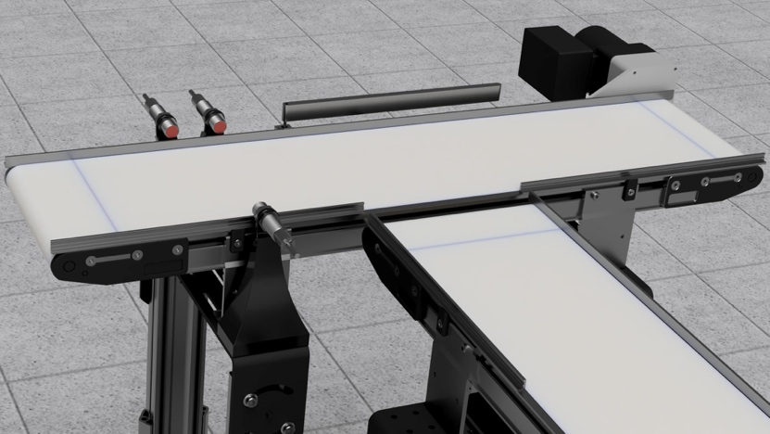
1
6
2
5
4
3
Figure 1 : CAD Rendering of Assembly Line

- Photoelectric Sensor with accompanying Reflector located on other side of conveyor belt.
- Inductive Sensor located next to the Photoelectric Sensor.
- Servo Motor located on side of conveyor belt.
- Diverter Arm mounted to Servo Motor.
- PLC located underneath conveyor belt to save space and visual aesthetics.
- Conveyor Belts perpendicular to each other with one the horizontal belt being slightly higher than the vertical belt to ensure smooth transitioning.

Before programming the PLC, it would be useful to understand Relay Logic and Electrical Ladder Diagrams, as these are the roots of Ladder Logic Programming. The physical set up of a PLC can be daunting, so familiarizing oneself with the many different ports can be helpful. Instructions specific to this project will be given on the physical wiring connections as well as programming the code.

1. wiring diagrams
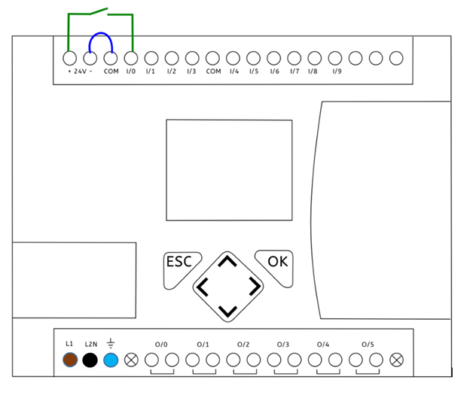
1.
2.
Figure 2: PLC Top Display

Legend for Figure 2

- DC Power Supply
Brown – Connection to +24 V terminal
Black – Connection to –24 V terminal
Blue – Grounded to 0 V

- Inputs
Color - Inductive sensor port
Color - Proximity Switch

- Output(s)
Color – Stepper Motor port

2. Inputting Devices into program

3. Basic Instructions
- Connect MicroLogix 1100 PLC to a 100 – 125V AC to 24V DC converter
  - Be sure AC to DC converter consist of 3 prongs
- Follow Figure 2 and legend to input wires from Inductive sensor, capacitive sensor, and stepper motor into screw terminals of MicroLogix 1100
  - Screw terminal use micro slotted screwdriver
  - Be sure to strip protective coating on ends for exposure to wire
- Navigate LED display on Micrologix1100 to run program installed on device
- Turn on the MicroLogix 1100 PLC and conveyor belts.

Setting up PLC via Ethernet Cable

Before beginning be sure the following software are downloaded to your hard drive.
  - BOOTP – DHCP Tool
  - RSLinx Classic Lite
  - RSMicroLogix Lite
If the PLC is not initially configured, (New from box), follow the steps listed below to set start initializing and programming:
- Locate the ethernet port, on left side of PLC facing upward, to connect the MicroLogix 1100 to a computer. Configurations are now needed for the device on the computer

- The first step in the process is going to the network settings within the control panel. Control Panel -> Network and Sharing Center -> Change adapter settings.

- Change adapter settings, click on properties -> Ip versions four,
  - Be sure obtain an IP address automatically is selected.

BOOTP – DHCP Tool

- Go into start programs select Rockwell software launch the BOOTP – DHCP Tool
  - This tool finds connections to hardware via Ethernet cord.
  - Wait 2 to 3 minutes for PLC Ethernet Address to appear in box.
    - If ethernet address is not showing something is wrong try unplugging PLC and plugging back in.
  - Select PLC ethernet address that displays on LED of PLC.
    - Be sure not to select wrong address as multiple addresses will be shown within this box
  - The MAC address on the screen will match the MAC address displayed on LED The Type should be BOOTP initially
  - Select add relation. Fill in IP address with local subnet IP address.
    - Once entered IP address it will transfer into entered relations box.
    - The IP address is not yet set on PLC side however it is set on BOOTP
  - Select disable bootTP/DHCP
    - Once selected The MAC address and the IP address will reflect on PLC and computer screen.
  - Close this utility as you will be able to connect to PLC with ethernet
- After connecting check computer settings
- Go into control panel -> network and sharing Center
- Select local area connection, or ethernet, select properties
  - Confirm you are on the same IP address as the PLC.
- Select use the following IP address and update the address as before
  - Be sure the last digits are different of IP Address then the last digits of IP Address of the PLC as it will not connect.
  - Once confirmed close tabs

RSLinx Classic Lite

- Go into all programs Rockwell software and RSLinx
  - Select RS who button
  - Select communications and RS drivers select ethernet devices from list or ethernet/IP driver select add new
  - Give a unique name for the new driver
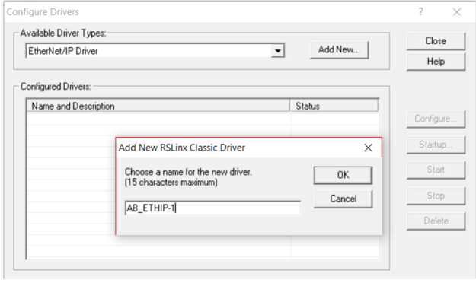
  - browse the local subnet and use the windows default
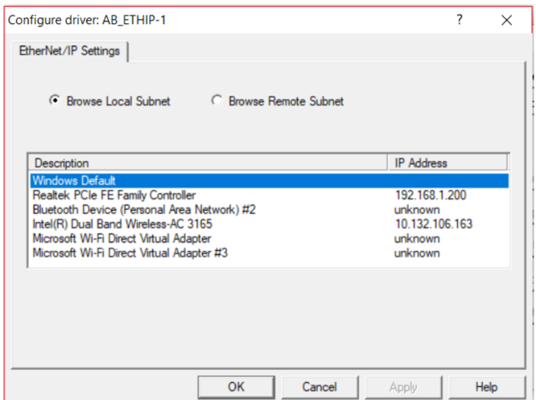
  - Select close
    - You are now able to browse with the PLC. If there is a big X located on the screen then the PLC is not connected correctly.
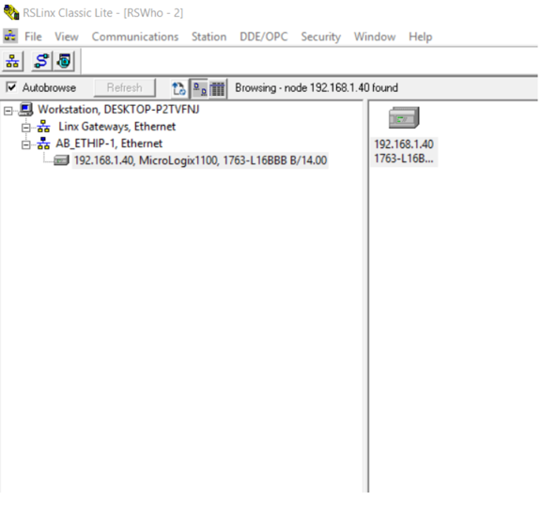

Go online with PLC

- Select start Rockwell RSLogix Micro starter Lite
- Create new program and select the correct PLC from list provided

To download project onto board

- Select comms -> System Comms. Locate driver.

- Select the controller and download.
  - You will be asked to name the project.
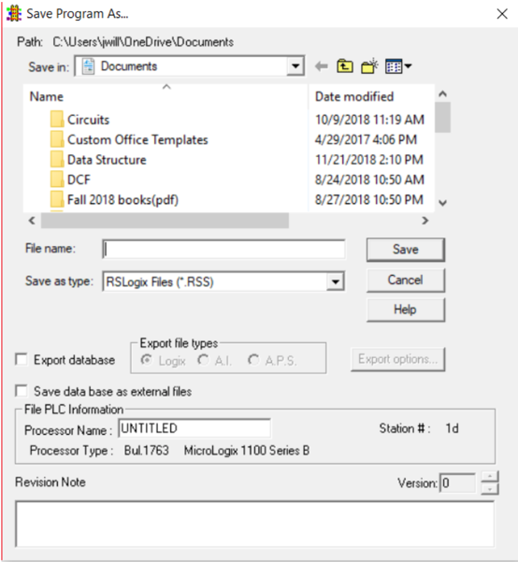
  - Once saved you will have the option to proceed with download or to cancel. The processor will need to be in program mode before downloading the program onto the PLC select apply new configuration
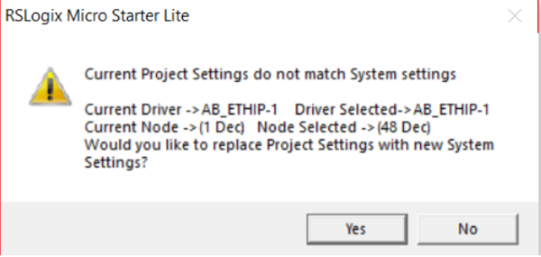
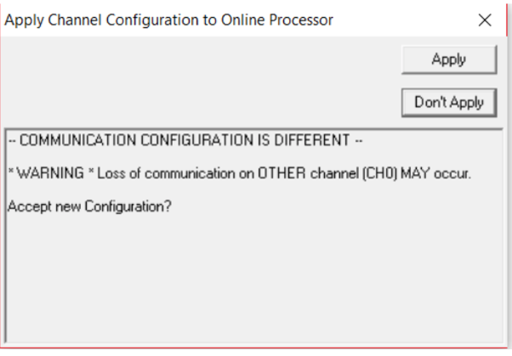
- There will be Rockwell simple turning to indicate that the PLC is in run mode along with a green box containing the words “REMOTE RUN” and the rungs will be green. For any troubleshooting check manual
- Check MicroLogix 1000 for operating manuals connected to setup

4. PSEUDOCODE
Logic given in on and off bits
1 & 1 reads Metal detection
0 & 1 reads plastic

5. TROUBLESHOOTING TIPS
- If wires are too small or large connections will not be made to and from Micrologix 1100
- SIDE NOTE: Connection wires from the power supply, inputs, and outputs should be between 12 and 20 AWG
- If sensors are not functioning check the connections on ground and the negative power supply.
- Some devices are NPN (connecting ground to black wire and negative power supply to the blue wire) while others are PNP (Connecting black wire to ground and the blue wire to the negative supply) devices.

REFERENCES
List of references must follow A.P.A. style.

